Assignment 4: Docker
one repo -- three branches -- master, 2026Q1, 2026Q2 -- all three have index.html files in them
JM -- use jenkins declarative pipeline—
create three containers c1 – master, c2 - Q1, c3 - Q2
bind c1 - 80
bind c2 - 90
bind c3 – 8080
Just using docker volume

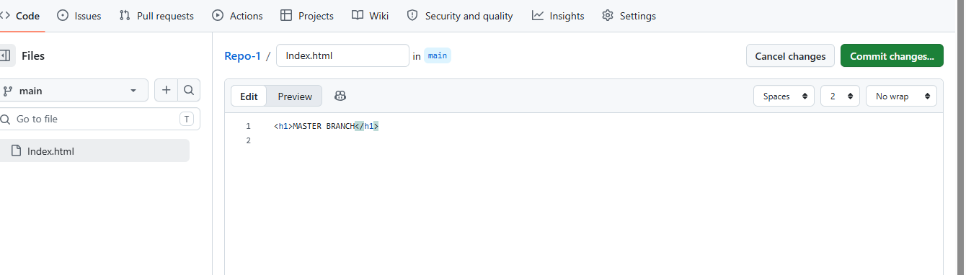

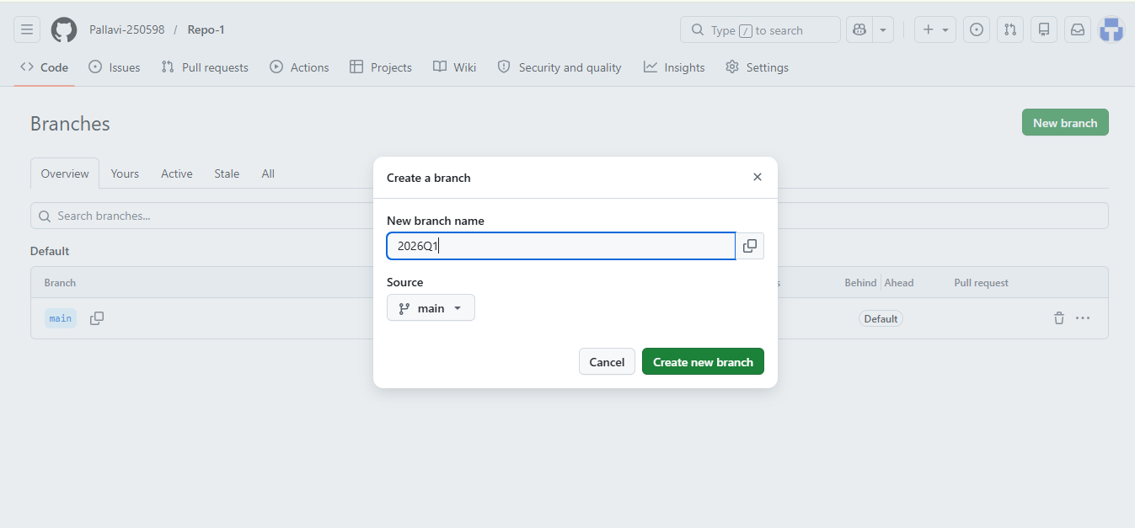

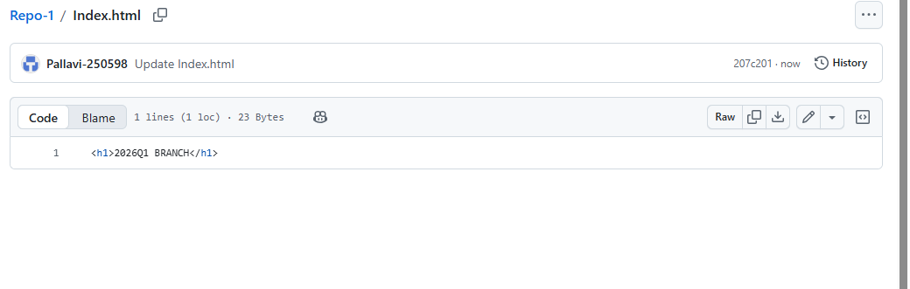
Install Jenkins in this server

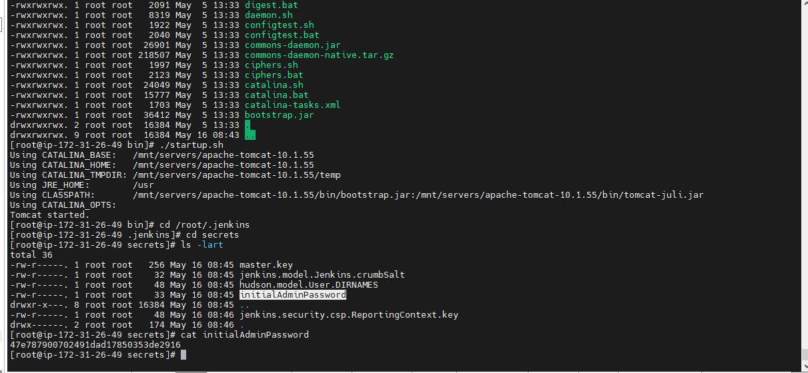

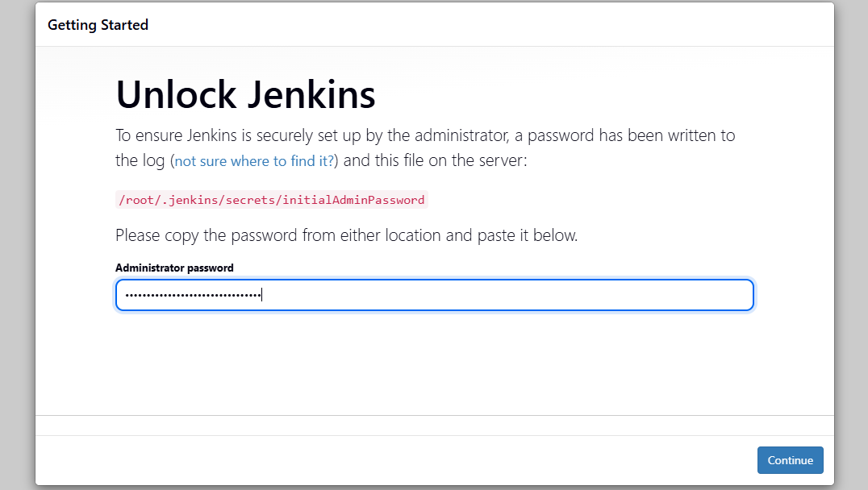

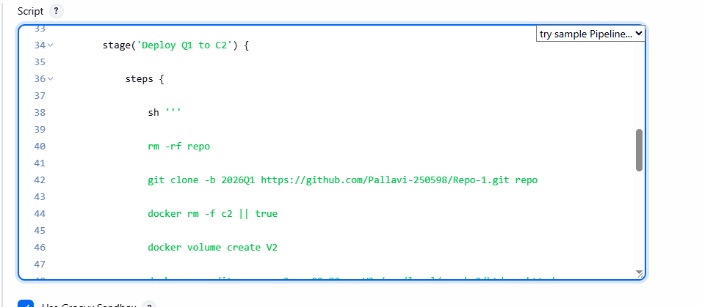

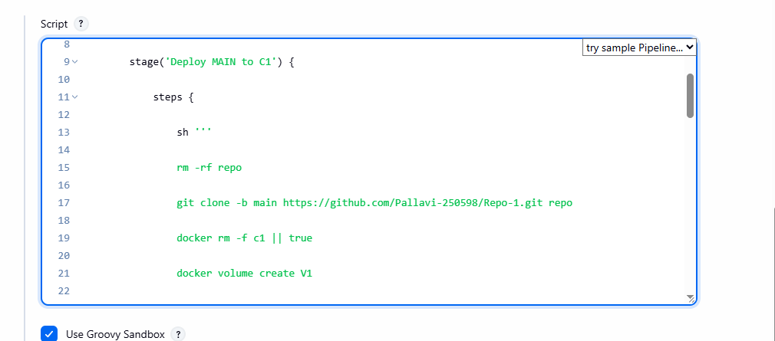

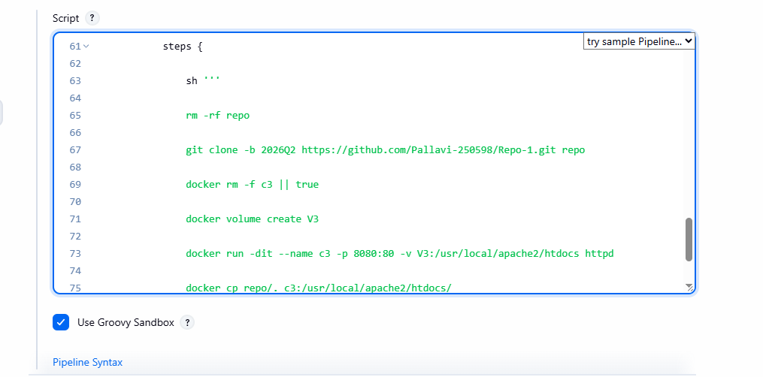

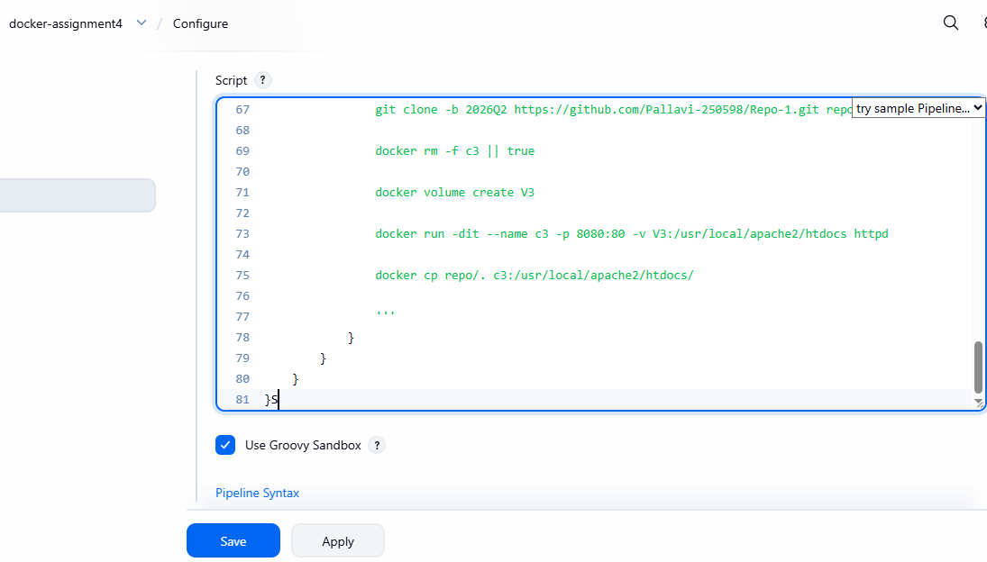

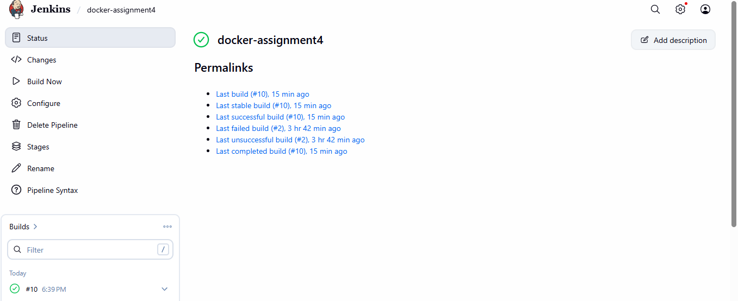

Run Jenkins job :
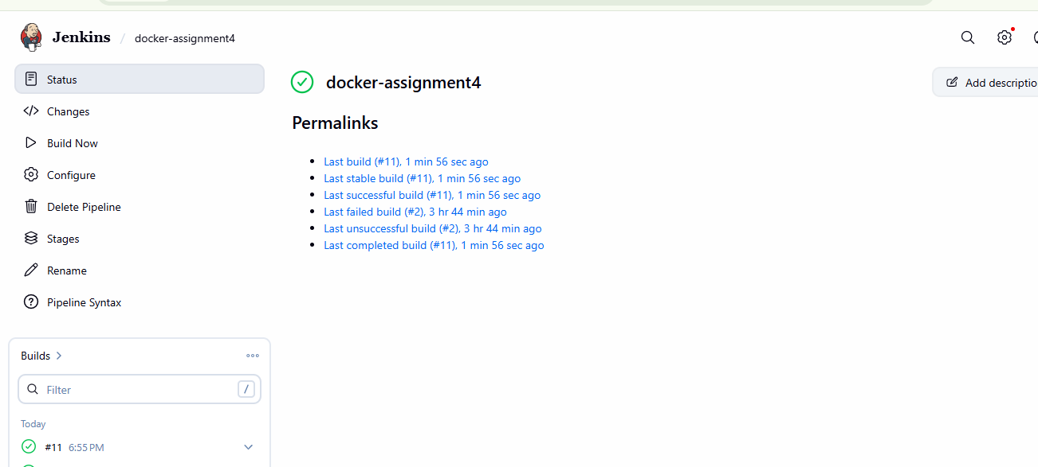

Container will be visible in server:
http://98.93.253.8:80

http://98.93.253.8:90
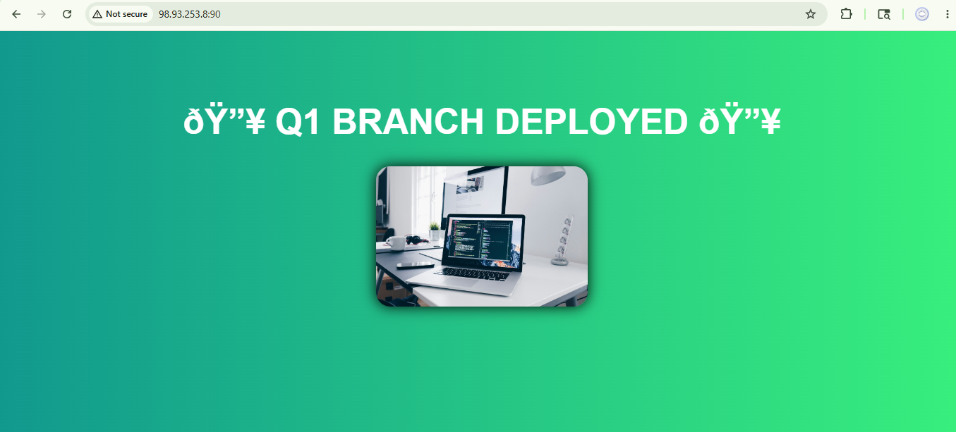

pipeline {

agent any

stages {

// ================= MAIN =================

stage('Deploy MAIN to C1') {

steps {

sh '''

rm -rf repo

git clone -b main https://github.com/Pallavi-250598/Repo-1.git repo

docker rm -f c1 || true

docker volume create V1

docker run -dit --name c1 -p 80:80 -v V1:/usr/local/apache2/htdocs httpd

docker cp repo/. c1:/usr/local/apache2/htdocs/

'''
}
}

// ================= Q1 =================

stage('Deploy Q1 to C2') {

steps {

sh '''

rm -rf repo

git clone -b 2026Q1 https://github.com/Pallavi-250598/Repo-1.git repo

docker rm -f c2 || true

docker volume create V2

docker run -dit --name c2 -p 90:80 -v V2:/usr/local/apache2/htdocs httpd

docker cp repo/. c2:/usr/local/apache2/htdocs/

'''
}
}

// ================= Q2 =================

stage('Deploy Q2 to C3') {

steps {

sh '''

rm -rf repo

git clone -b 2026Q2 https://github.com/Pallavi-250598/Repo-1.git repo

docker rm -f c3 || true

docker volume create V3

docker run -dit --name c3 -p 8080:80 -v V3:/usr/local/apache2/htdocs httpd

docker cp repo/. c3:/usr/local/apache2/htdocs/

'''
}
}
}
}

